**Assignment Advance Programming Lab**

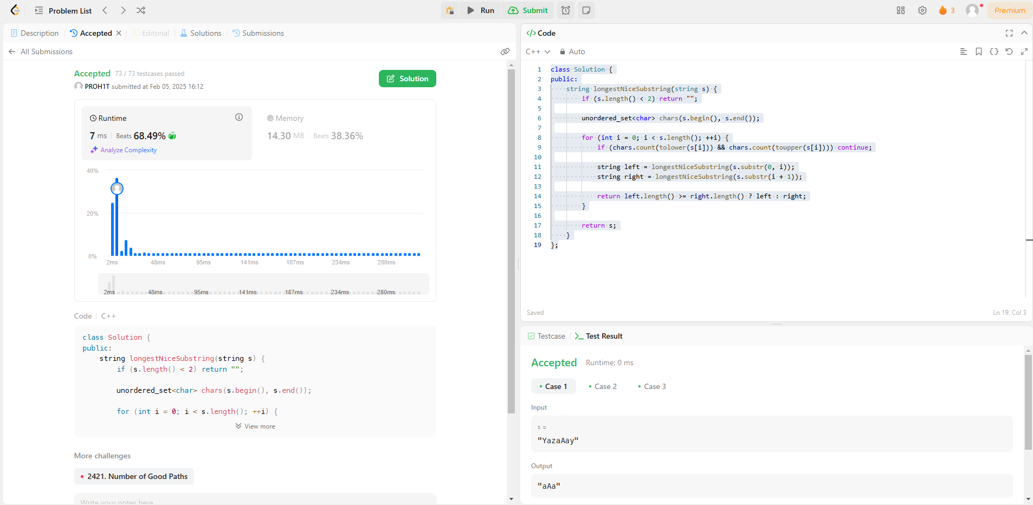 [**1763. Longest Nice Substring**](https://leetcode.com/problems/longest-nice-substring/)

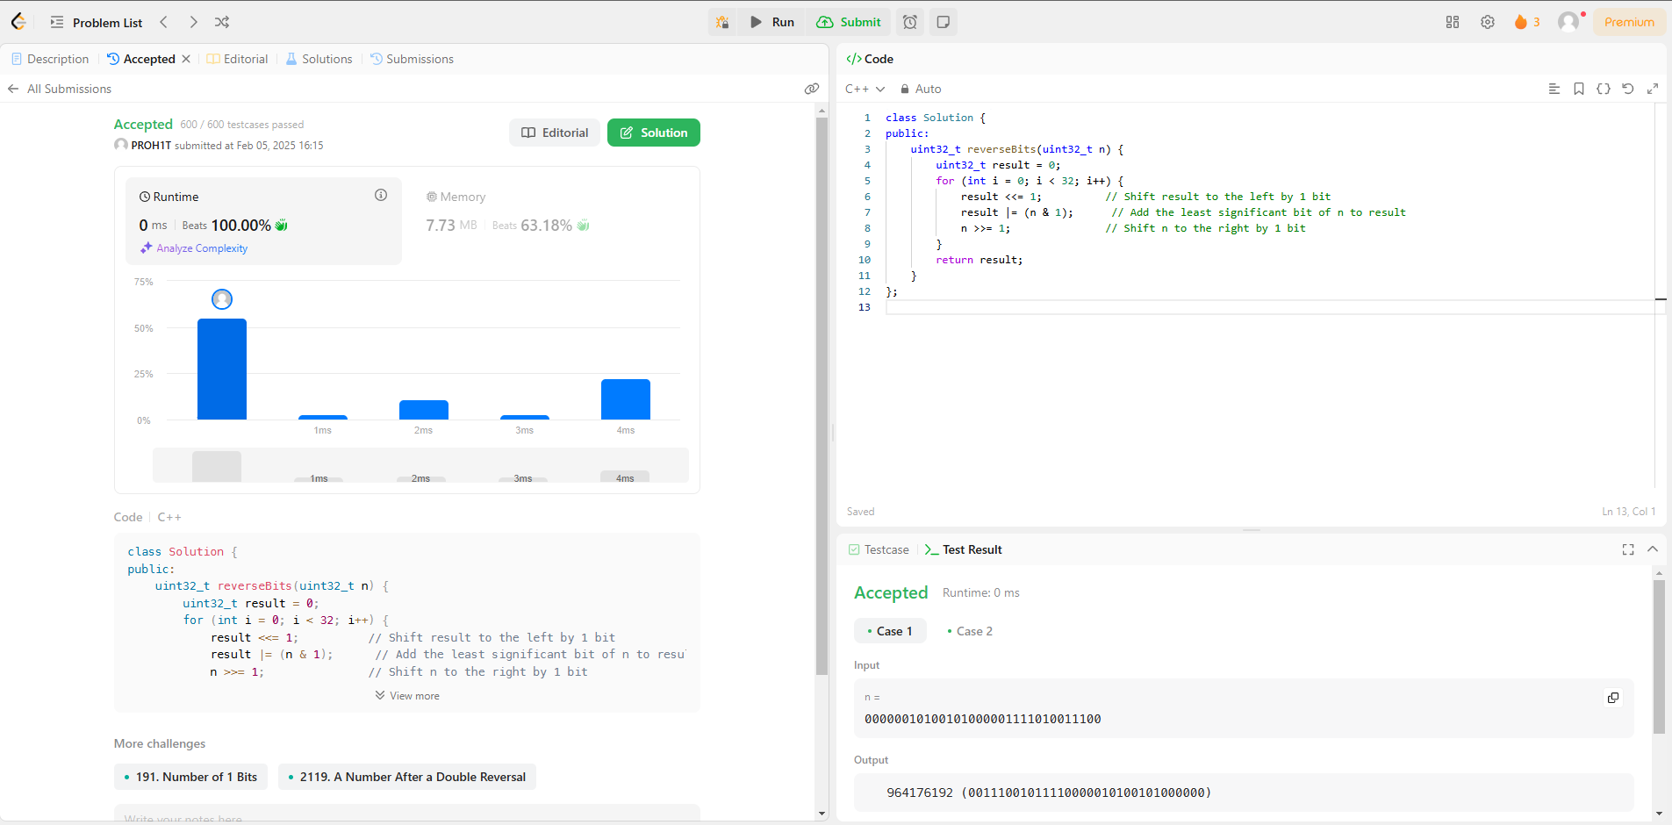[**190. Reverse Bits**](https://leetcode.com/problems/reverse-bits/)

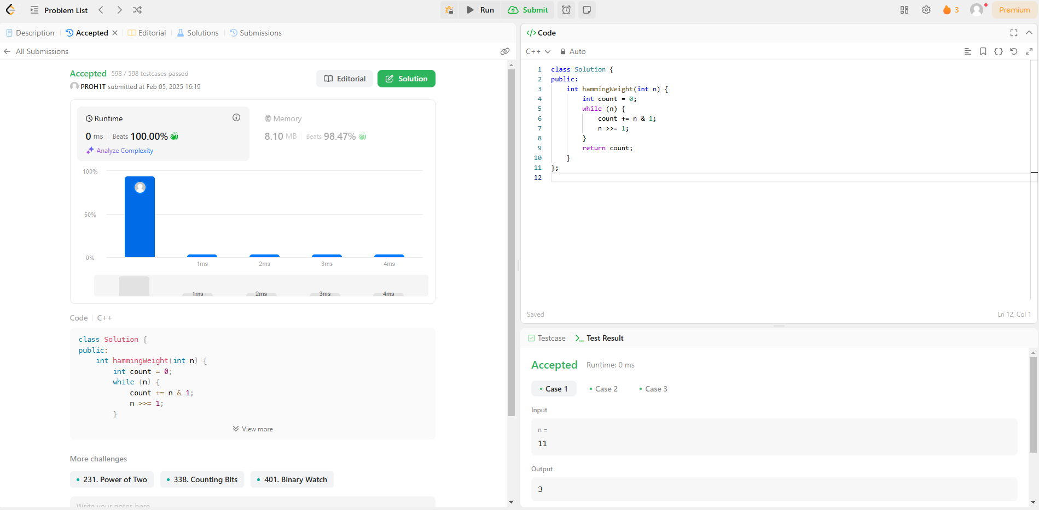[**191. Number of 1 Bits**](https://leetcode.com/problems/number-of-1-bits/)

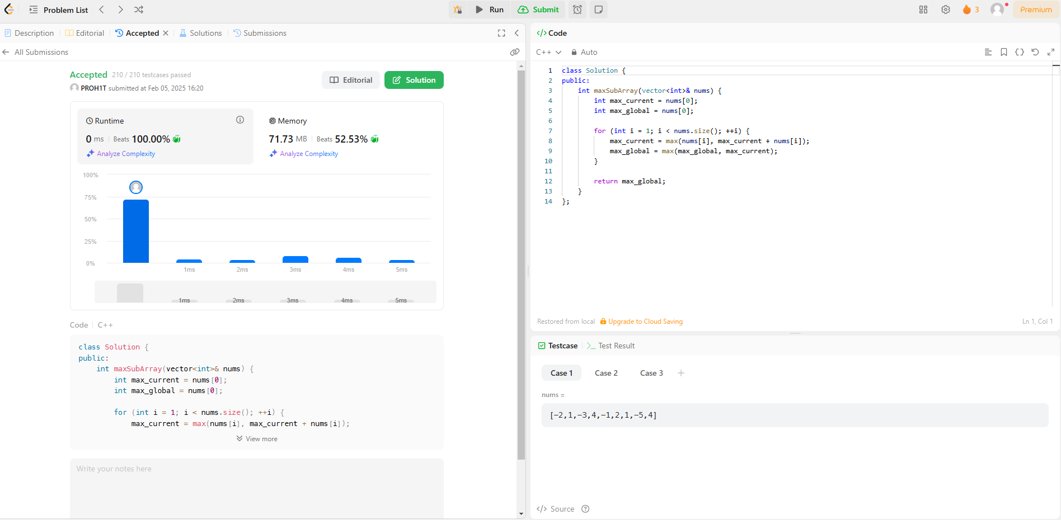[**53. Maximum Subarray**](https://leetcode.com/problems/maximum-subarray/)

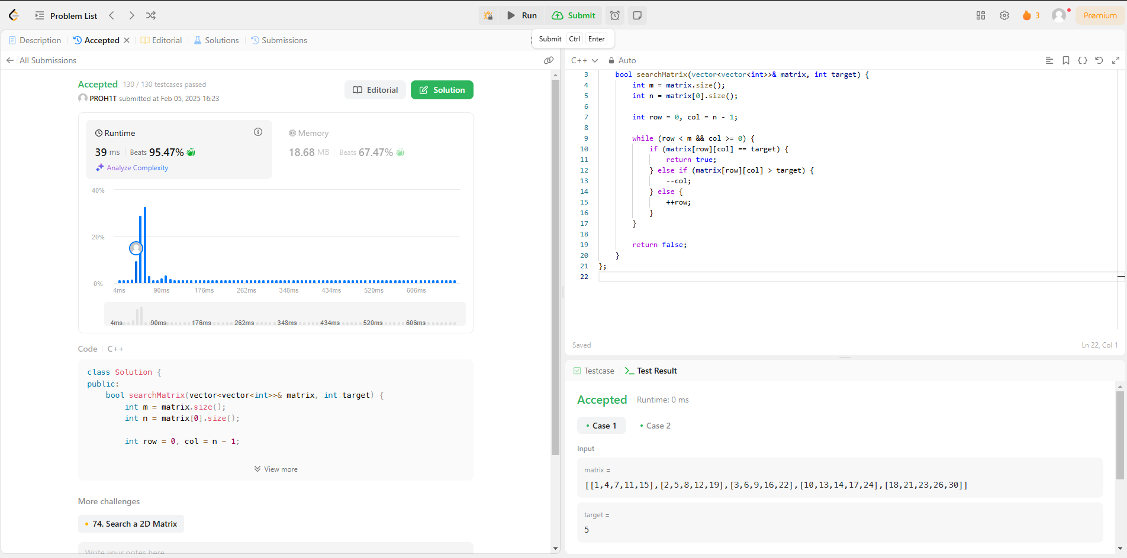[**240. Search a 2D Matrix II**](https://leetcode.com/problems/search-a-2d-matrix-ii/)

[**372. Super Pow**](https://leetcode.com/problems/super-pow/)

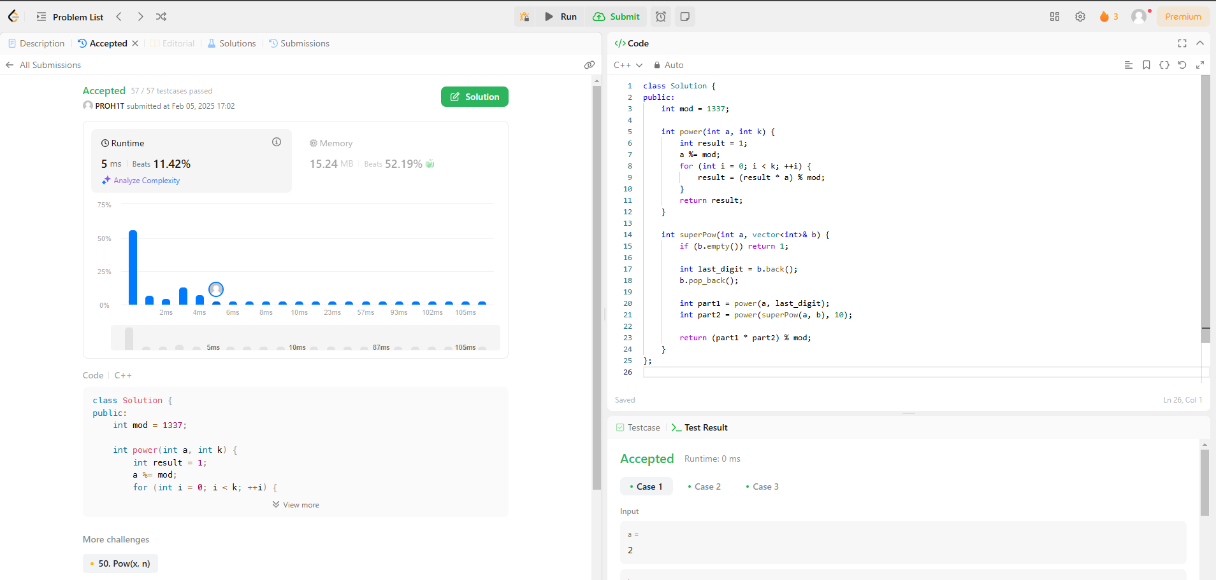

[**932. Beautiful Array**](https://leetcode.com/problems/beautiful-array/)

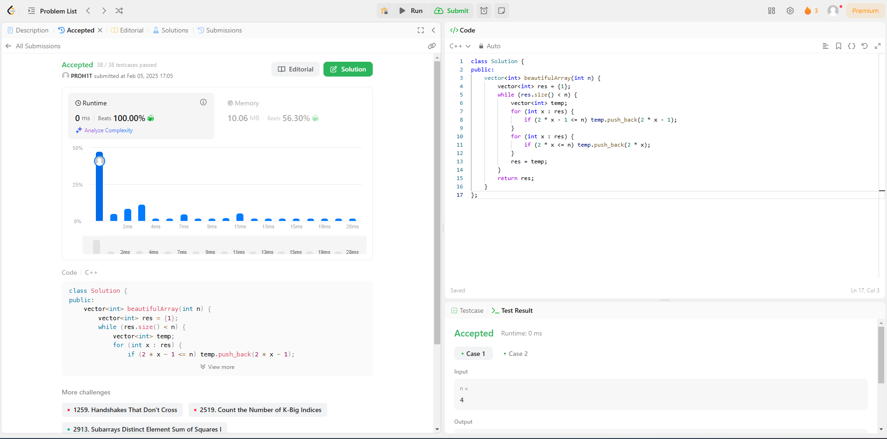

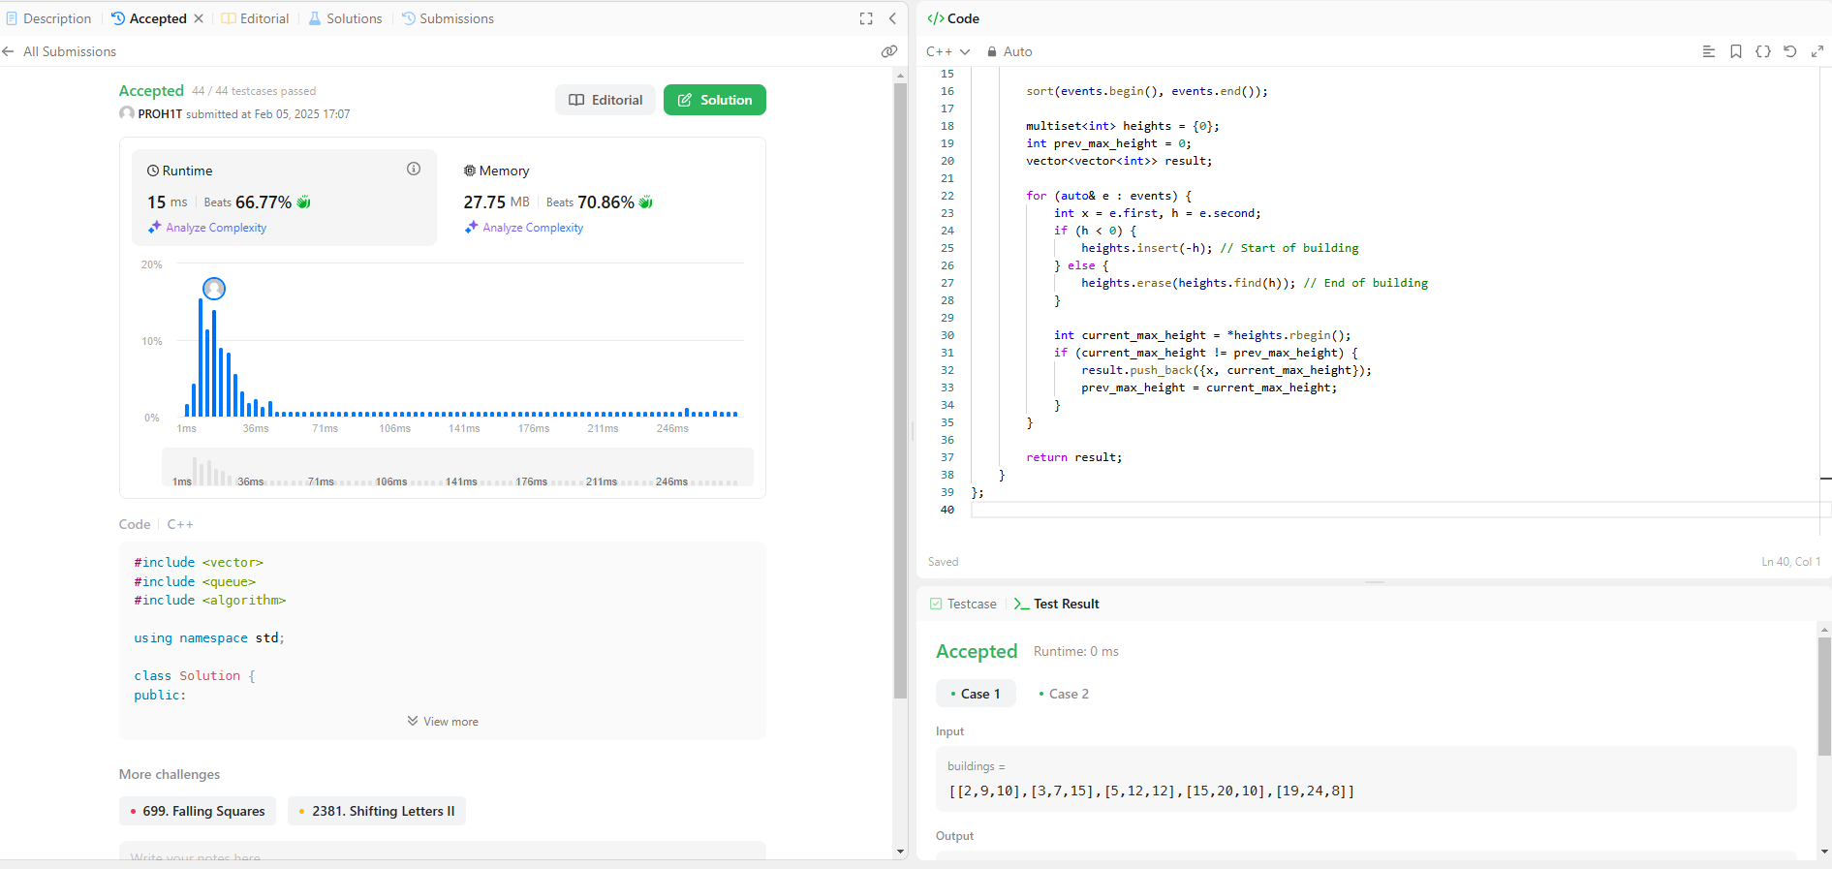[**218. The Skyline Problem**](https://leetcode.com/problems/the-skyline-problem/)

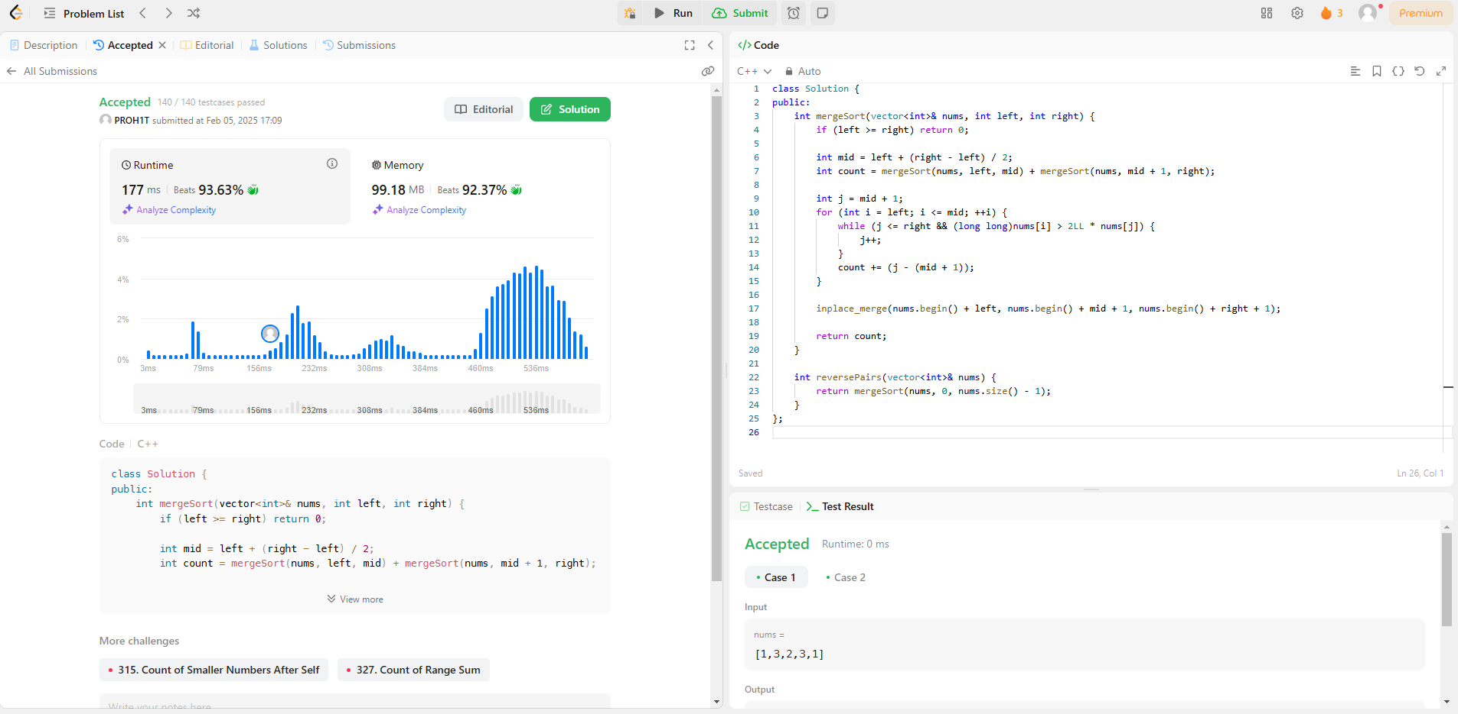[**493. Reverse Pairs**](https://leetcode.com/problems/reverse-pairs/)

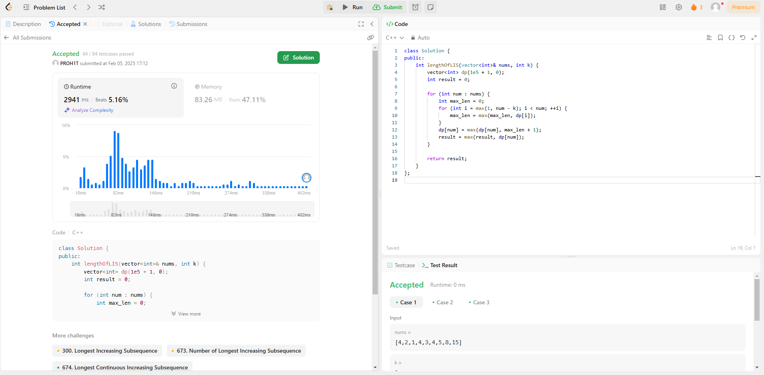[**2407. Longest Increasing Subsequence II**](https://leetcode.com/problems/longest-increasing-subsequence-ii/)

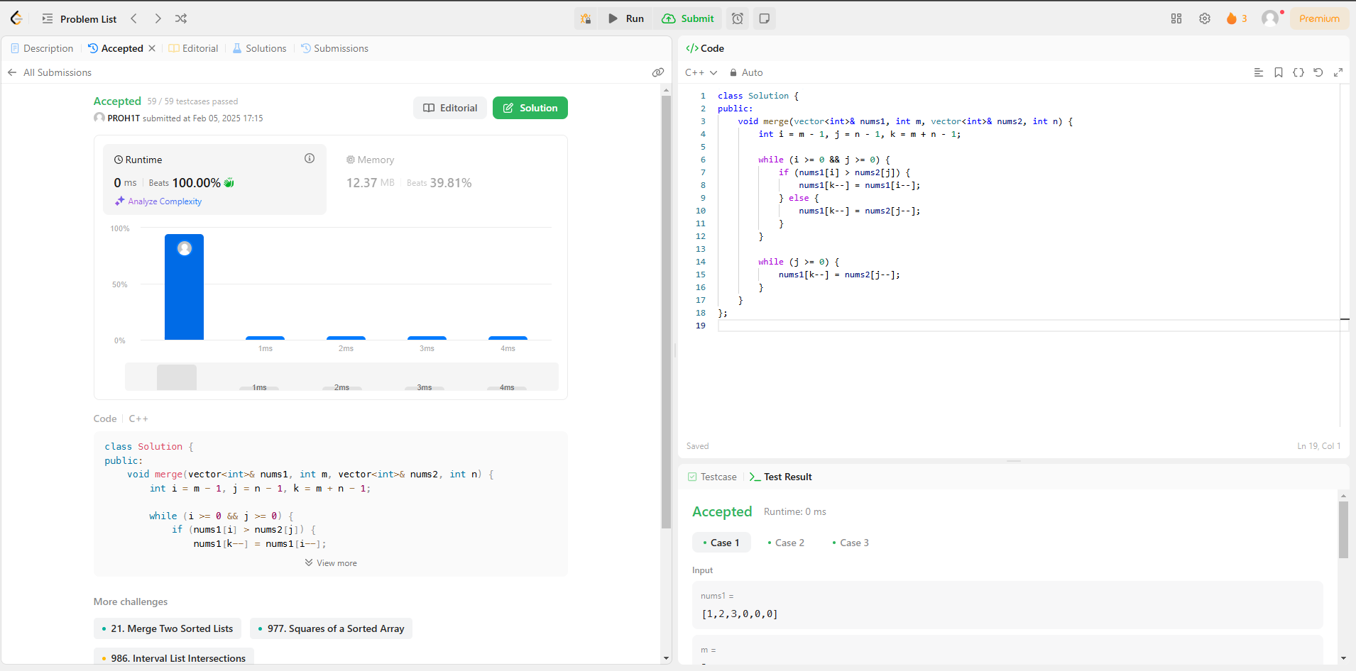[**88. Merge Sorted Array**](https://leetcode.com/problems/merge-sorted-array/)

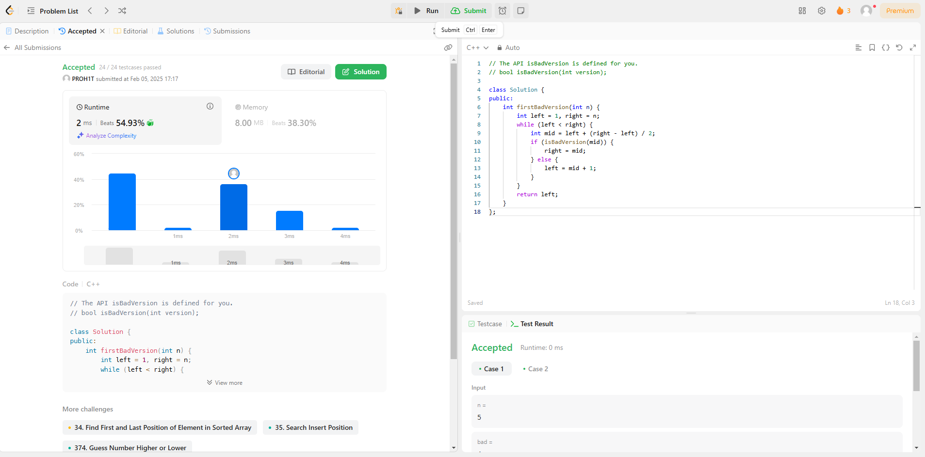[**278. First Bad Version**](https://leetcode.com/problems/first-bad-version/)

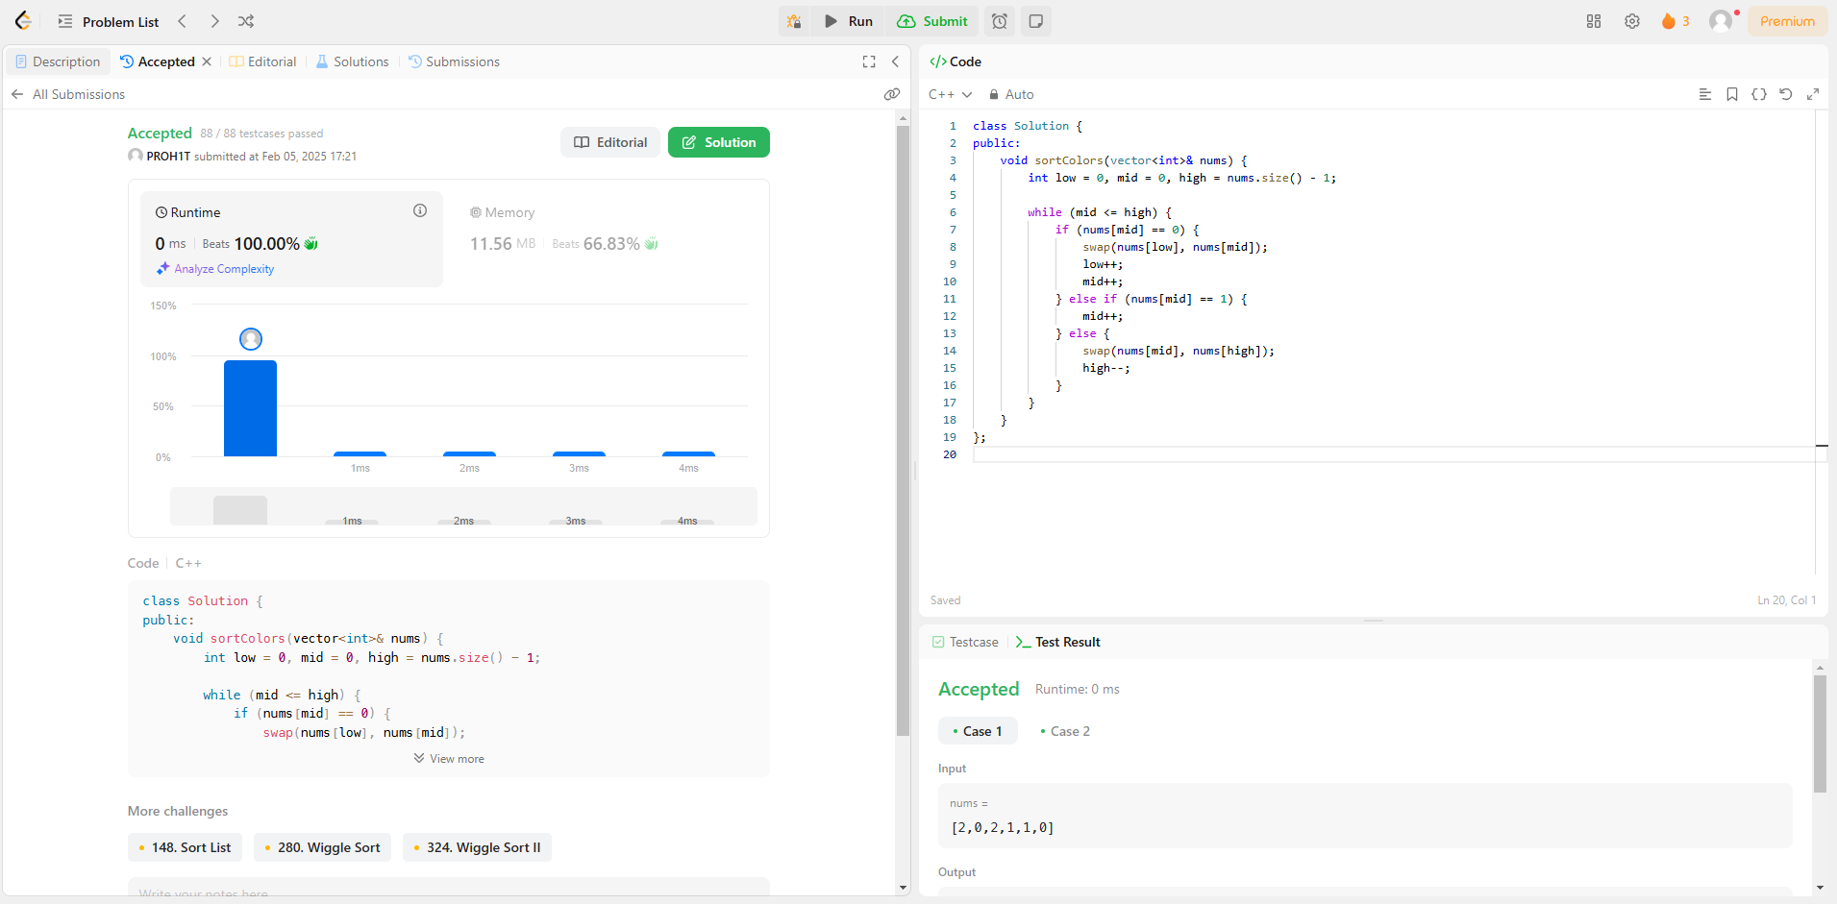[**75. Sort Colors**](https://leetcode.com/problems/sort-colors/)

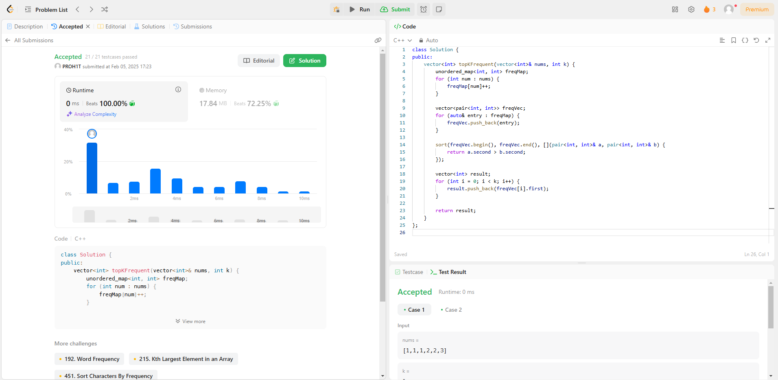[**347. Top K Frequent Elements**](https://leetcode.com/problems/top-k-frequent-elements/)

[**215. Kth Largest Element in an Array**](https://leetcode.com/problems/kth-largest-element-in-an-array/)

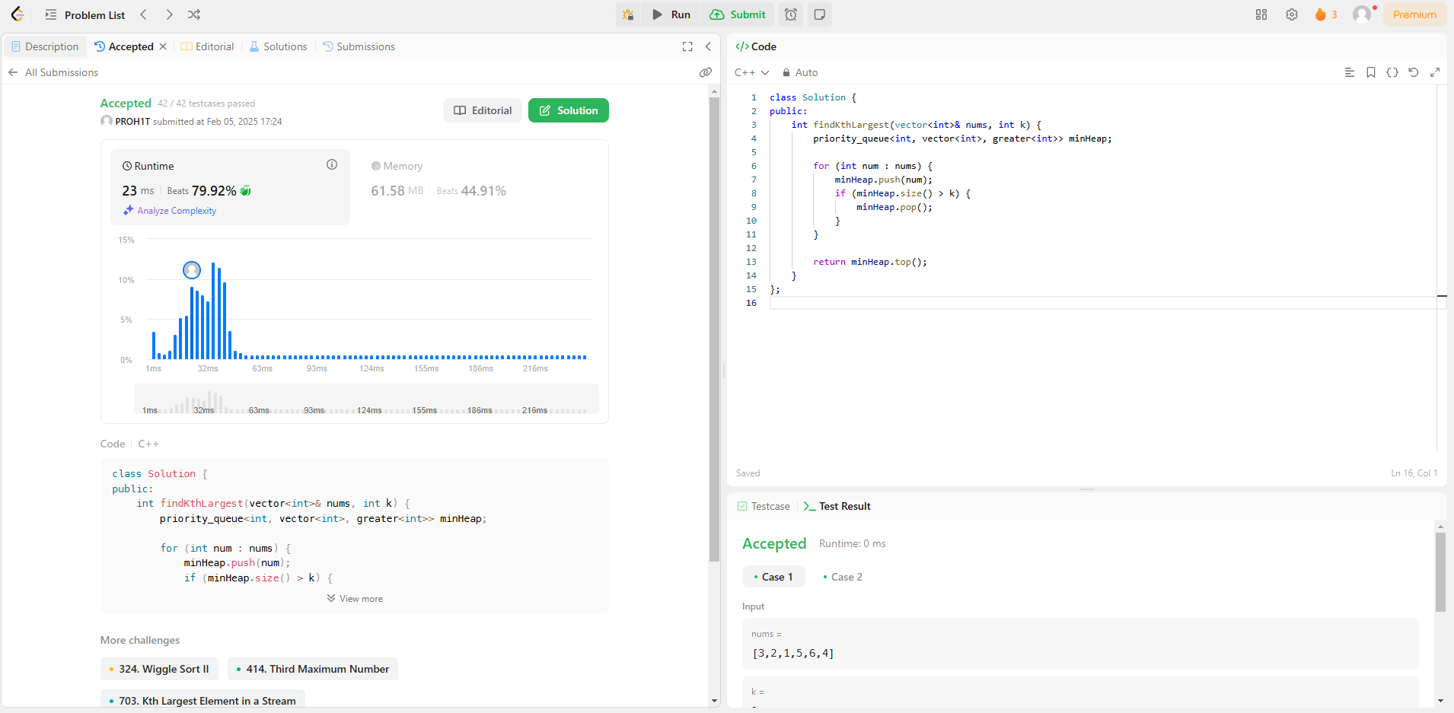

[**162. Find Peak Element**](https://leetcode.com/problems/find-peak-element/)

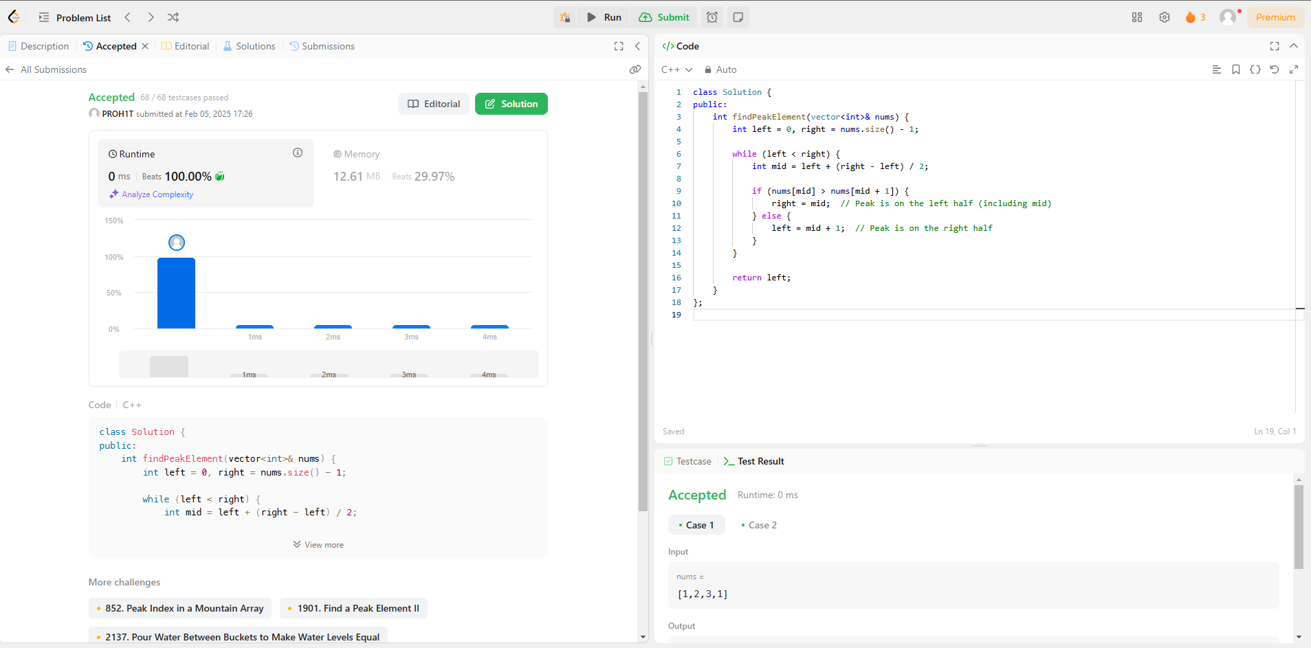

[**56. Merge Intervals**](https://leetcode.com/problems/merge-intervals/)

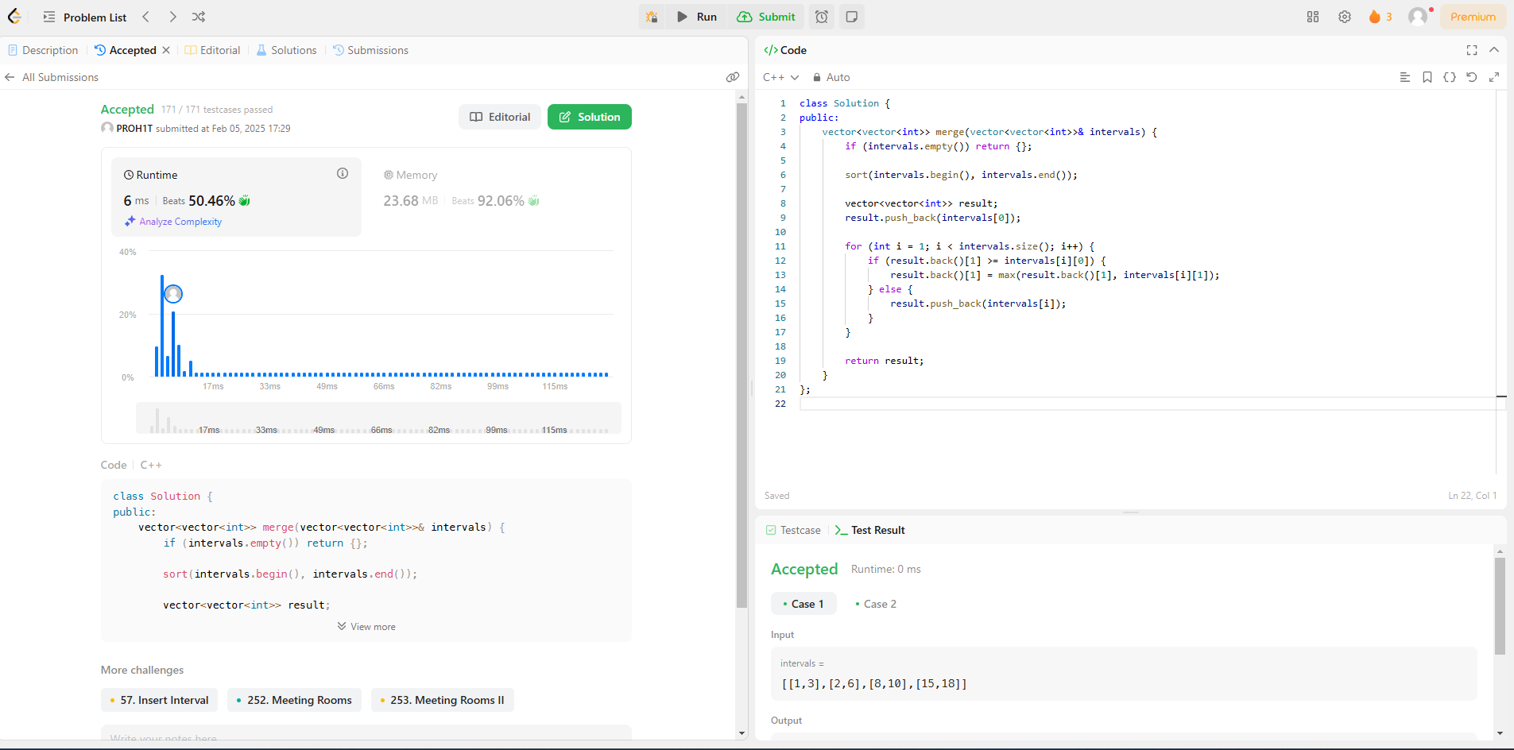

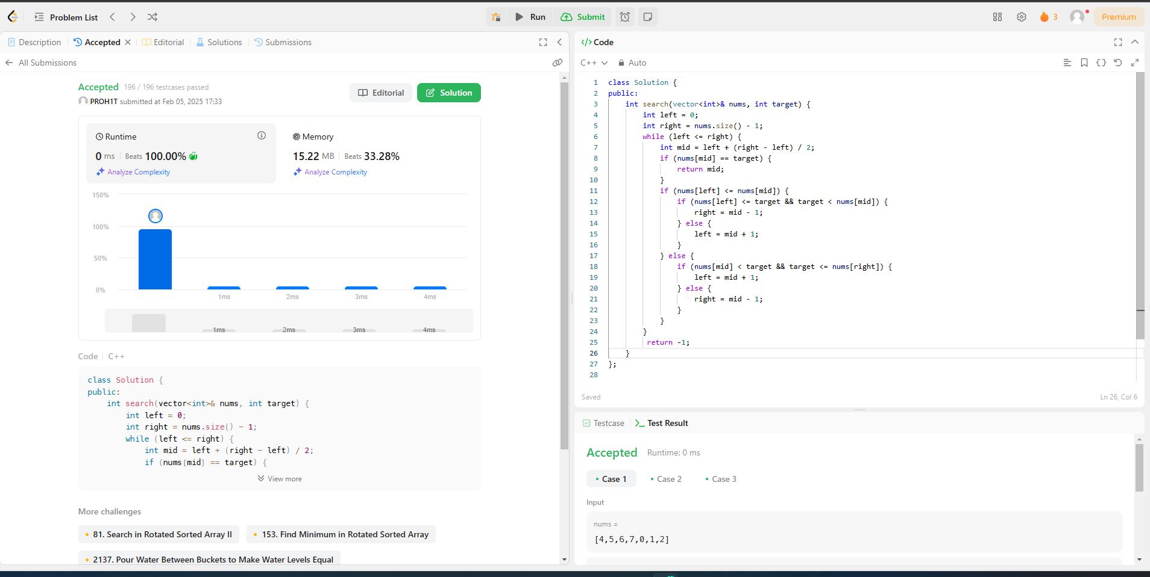[**33. Search in Rotated Sorted Array**](https://leetcode.com/problems/search-in-rotated-sorted-array/)

[**240. Search a 2D Matrix II**](https://leetcode.com/problems/search-a-2d-matrix-ii/)

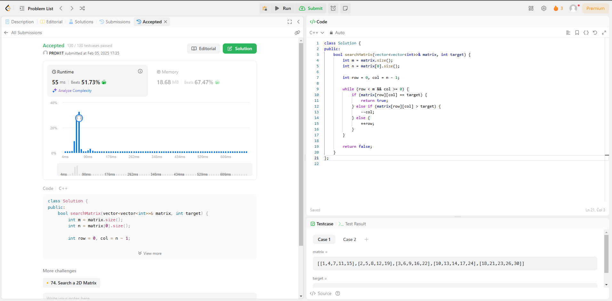

[**324. Wiggle Sort II**](https://leetcode.com/problems/wiggle-sort-ii/)

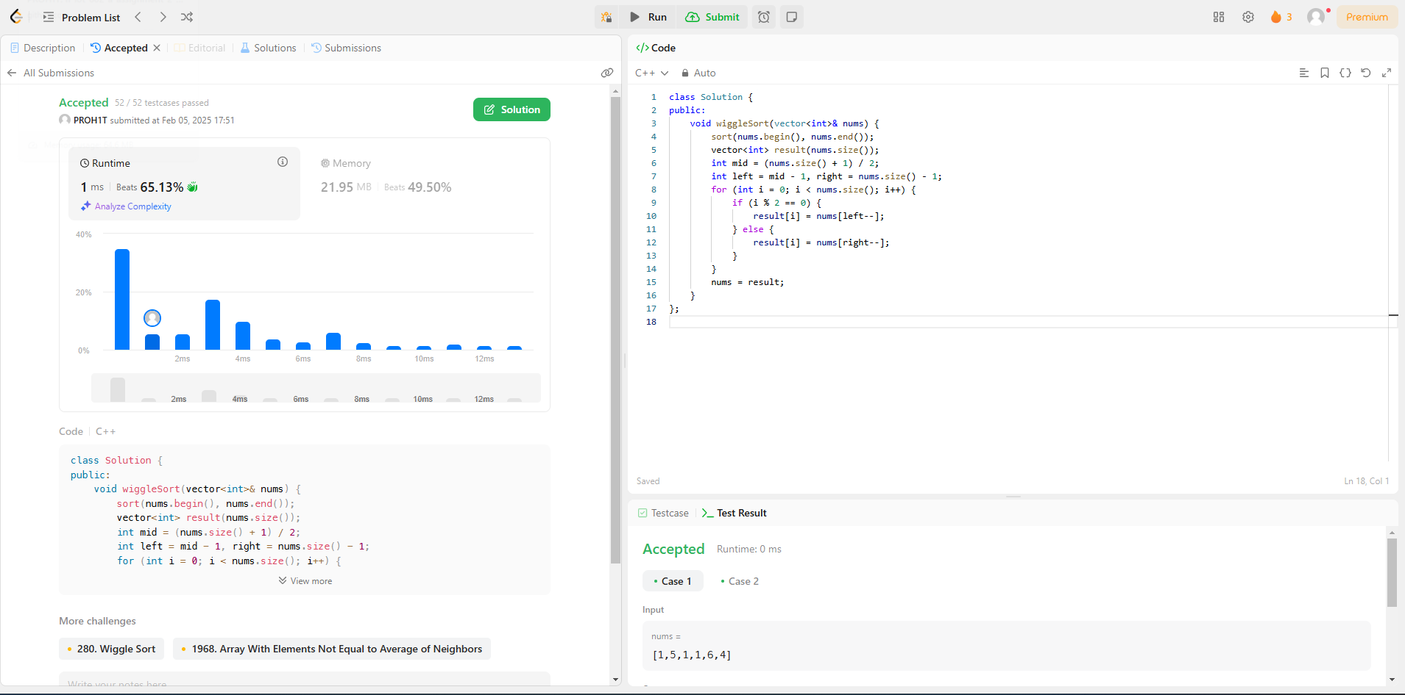

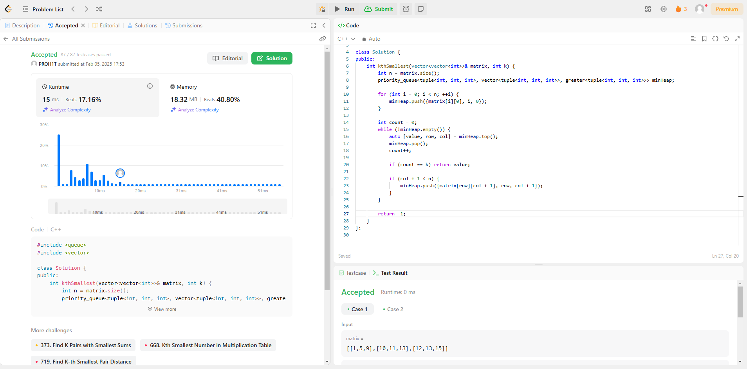[**378. Kth Smallest Element in a Sorted Matrix**](https://leetcode.com/problems/kth-smallest-element-in-a-sorted-matrix/)

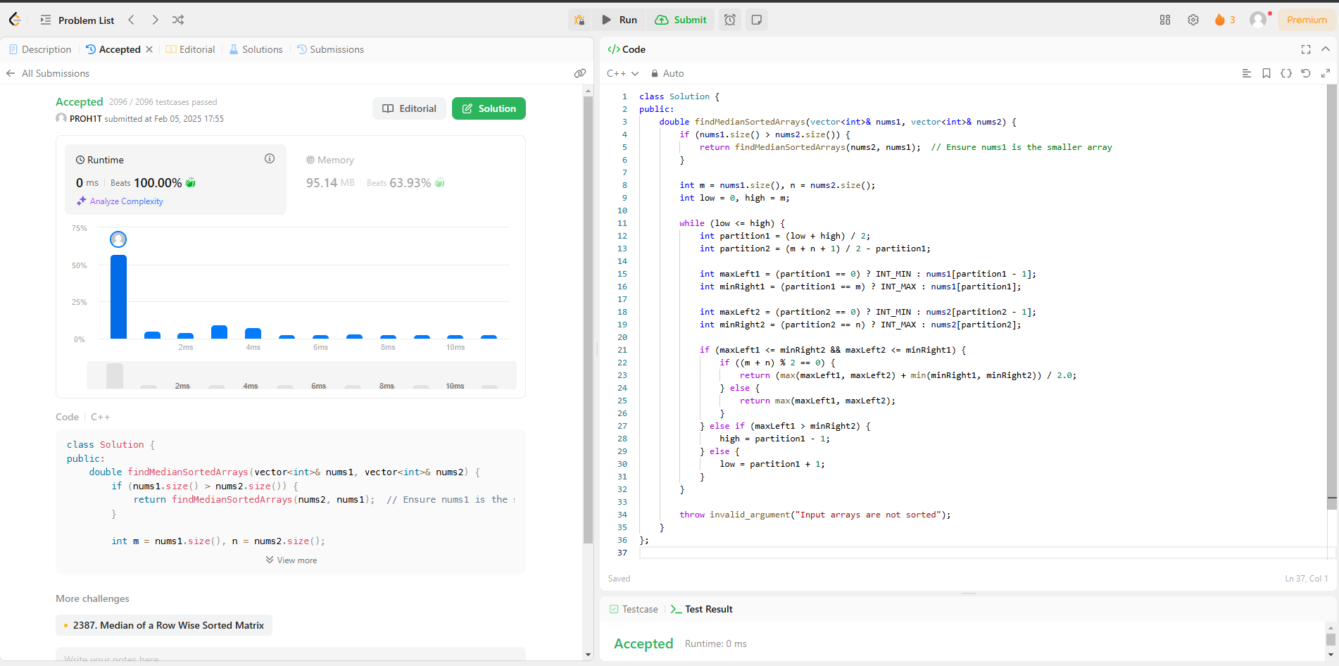[**4. Median of Two Sorted Arrays**](https://leetcode.com/problems/median-of-two-sorted-arrays/)